 

**Technion— Israel Institute of Technology, Haifa, Israel, Department of Electrical Engineering**



**Maxeler Deep Learning – id 2984**

**Final Report**

By: **Yogev Dotan, Dor Rosenblum**

Supervisors: Oz Shmueli, Chaim Baskin

**November 2017**

Table of Contents

Revision History 5

Glossary 6

1. Abstract 7

1.1. Short Background on Deep Learning 7

1.2. Project Goals 7

2. Introduction to Artificial Neural Networks and Deep Learning 8

2.1. What is Neural Network? 8

2.1.1. Neuron Element and Activation Function 8

2.1.2. Learning Process 8

2.1.3. Feedforward Calculation 9

2.1.4. Backpropagation Correction 9

2.2. What is Deep Learning? 10

2.3. Main Challenges of Implementing Embedded ANNs 11

2.3.1. Require Flexibility of A lot of Parameters 11

2.3.2. Built in Data Type Precision Inherent Error 11

2.3.3. Expensive Activation Functions Computation 11

2.3.4. Backpropagation Dictates Saving Nets Full State 11

2.3.5. No new Feedforward Pipeline during Backpropagation Update 12

2.3.6. Vastly Different DataSets Formats 12

3. Platform Selection - CPU vs FPGA (Barney, 2016) 13

3.1. Why CPUs 14

3.2. Why Not CPUs 14

3.3. Why FPGAs 14

3.4. Why Not FPGAs 14

3.5. FPGA Programing Made Simpler 14

4. Maxeler Platform 15

4.1. Maxeler Approach and Purpose 15

4.2. Maxeler Usage Outline 15

4.3. Maxeler Internal Structure (Maxeler.com, 2011) 16

4.3.1. PATH - Data Flow Engines 16

4.3.2. CONTROL- Main Processor/CPU Host 17

5. Design Considerations 18

5.1. Problem Statement & Addressing the Challenges 18

5.2. Overview of Existing Solutions 19

5.2.1. Not Using Deep Learning Software Libraries 19

5.2.2. Not Using FPGAs Explosively 19

5.3. Leading to the Best Design 19

6. Proposed Solution 20

6.1. Concept 20

6.1.1. Our Goals: Plan a Fully Connected ANN Hardware Generic Building Blocks and Implement it over the Maxeler 20

6.2. Architecture 21

6.2.1. Tasks Division 21

6.2.2. Communications between Elements 21

7. Implementation Overview 23

7.1. Environment 23

7.2. Application Usage Flow 23

7.2.1. User API and Parameters 23

7.3. Application Layer 25

7.3.1. CPU Load DataBase & Initialize ANN Model 25

7.3.2. DFE Feedforward & Backpropagation of the Fully Connected ANN of 1 Epoch 27

7.3.3. Non Blocking CPU prepare next Epoch & Statistics 37

7.3.4. CPU Stop condition & save ANN Model 39

8. Development Process 40

8.1. Development Methodologies 40

8.2. Design Patterns 43

9. Testing 45

9.1. Simulation Unit Testing 45

9.2. Simulation Integration Testing 45

9.3. Functional Synthesized Hardware Testing 48

9.4. Performance Testing (Kelleher, 2013) 48

9.4.1. Resource Utilization 48

9.4.2. Accuracy 49

10. An "HOW TO" Guide 53

10.1. Build & Run Golden Model 53

10.2. Import DFE Project 55

10.3. Prepare DFE Setting Before Build 55

10.4. Build & Run & Compare DFE 58

10.5. Result Plot 58

11. Future Work 59

11.1. Performance Optimizations (Zhang, 2015) 59

11.1.1. Bigger Better FPGA 59

11.1.2. Reducing Bit representation 61

11.1.3. Maxeler Ring – Usage of multiple FPGA 61

11.1.4. Thinner Topology 61

11.1.5. GPU link Topology 61

12. Bibliography 62

13. Requirements 63

13.1. Machine Learning ANN 63

13.2. Analysis and Evaluation 63

13.3. CPU Programing 63

13.4. Hardware and DataStream Design 63

13.5. Maxeler Developer Environment 63

# Revision History

|  |  |  |
| --- | --- | --- |
| date | by | main change |
| ‏15/10/2016 | Yogev Dotan, Dor Rosenblum | End of projects concept |
| ‏07/3/2017 | Yogev Dotan, Dor Rosenblum | Adding inner modules visoi |
| ‏03/09/2016 | Yogev Dotan, Dor Rosenblum | Final bibliography |
| 05/09/2016 | Yogev Dotan, Dor Rosenblum | Applying Oz's notes and feedbacks |
|  |  |  |
|  |  |  |

# Glossary

|  |  |
| --- | --- |
| Term | Definitions |
| ANN | artificial neural nets: a computational machine learning model based on the structure and functions of biological neural networks. |
| CPU | central processing unit / processor that carries out the instructions of a computer program. |
| DFE | Data Flow Engine |
| FPGA | field-programmable gate array, an integrated circuit that can be programmed in the field after manufacture. |
| SLiC | Simple Live CPU, automatically generated interface to the Maxeler dataflow program**.** |

# Abstract

## Short Background on Deep Learning

Deep Learning is an information processing system paradigm that is based on Artificial Neural Network (ANN) structure. i.e. a system composed of many highly interconnected processing elements working in unison to solve specific problems.

This has been proven to be very successful in many real-world problems, such as pattern recognition or data classification, through a *slow & complex* learning process:

Selecting the appropriate ANN architecture and data specific for a given problems is extremely complex, and most times demands an extensive process of trial and error- since there is No optimal mathematical model for every problem we try to solve.   
This issue makes developers and researchers undergo evaluation of different data preprocessing, model building and model evaluation OVER AND OVER AGIAN.

## Project Goals

Our *vision* is that **extreme acceleration of the computational process of the ANN workflow will enable easier experimentation of ANN architecture, larger data sets, shorter training duration, and faster results of computations**. Thus, advancing our understanding, the use and the fields that ANN technology can better our lives.

We will achieve this goal via a novel structure of generic ANN building blocks for a low-latency, massive parallelism, hardware accelerated, heterogenic system with the Maxeler.

# Introduction to Artificial Neural Networks and Deep Learning

In the first 2 chapters, we will review the topic.   
The later chapter will conclude the main challenges for applying this method.

## What is Neural Network?

An Artificial Neural Network (ANN) is an information processing paradigm that is inspired by the way biological nervous systems, such as the brain, process information – i.e. a special type of machine learning (ML) algorithm.

ANN is composed of many highly interconnected processing elements (aka *neurons* or nodes) working in unison to solve specific problems.

### Neuron Element and Activation Function

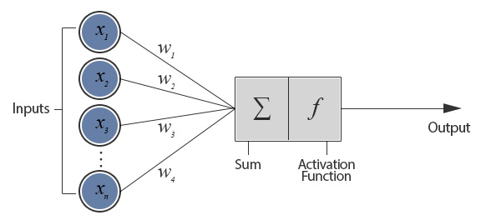The key element of this paradigm is the novel structure is the neuron.   
Its inputs are from the last layer, passing through an affine weighted transform  
(this transform could be described by a connectivity *weights* matrix and *bias* vector).   
The neuron then sums the result, and calculates a mathematical *activation function*.  
The function could differ depending on the type of data, and the layer's position in the net.   
linear ReLu, Log Sigmoid and Tan Sigmoid and Softmax transfer functions are used.

### Learning Process

Most ANNs learn by example. An ANN is configured for a specific application, such as pattern recognition or data classification, through a learning process.   
Learning in biological systems involves adjustments to the synaptic connections that exist between the neurons. This is true of ANNs as well.

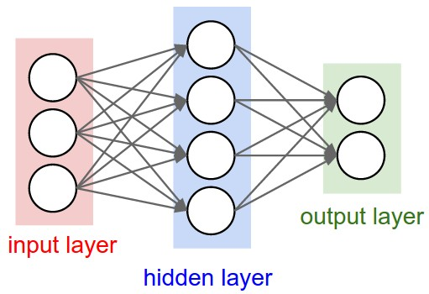neural networks differ from each other by the number of neurons in each layer, number of layers, and inter-connectivity among them.

on a given neural network model, the learning process sets each neuron behavior via many parameters.

while the learning process is a very demanding computation iteration, the classification itself has a low latency.

There are 2 phases in the net's use:

### Feedforward Calculation

A feedforward neural network is an ANN wherein connections between the units do not form a cycle: the information moves in only one direction, forward, from the input nodes, through the hidden nodes (if any) and to the output nodes.

After reaching the output node, in the end of the feedforward phase, we get the estimated ANN result and calculation is done. We can use it as we see fit.

When still in the learning process, the net can be corrected if this output is different than the desired output given the train data set via a phase called Backpropagation:

### Backpropagation Correction

Backpropagation (mazur, 2015) is a method used in artificial neural networks to calculate the error contribution of each neuron after a batch of data is processed. This is used by an enveloping optimization algorithm to adjust the weight of each neuron, completing the learning process for that case.

Technically it calculates the Gradient Decent of the loss function. It is commonly used in the gradient descent optimization algorithm. The error is calculated at the output and distributed back through the network layers.

Backpropagation requires a known, desired output for each input value.



## What is Deep Learning?

Deep learning methods aim at learning feature hierarchies with features from higher levels of the hierarchy formed by the composition of lower level features.   
Automatically learning features at multiple levels of abstraction allow a system to learn complex functions mapping the input to the output directly from data, without depending completely on human-crafted features.

Although early approaches published by Hinton and collaborators focus on greedy layer-wise training and unsupervised methods like autoencoders,   
modern state-of-the-art deep learning is focused on training deep (many layered) ANN models using the backpropagation algorithm as an efficient method to implement highly non-linear complex systems due to its “Universal Function Approximation” capabilities.

The most popular techniques are:  
- Multilayer Perceptron Networks.  
- Convolutional Neural Networks and Pooling.  
- Long Short-Term Memory Recurrent Neural Networks.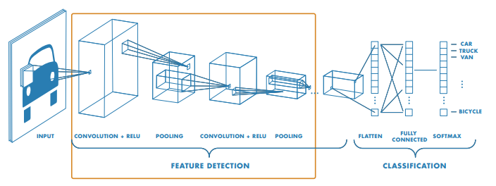

## Main Challenges of Implementing Embedded ANNs

After the introduction of ANN and deep learning, we will point out the main challenges faced when wanting to implement an accelerated Deep Learning Paralleled System:

### Require Flexibility of A lot of Parameters

The number of a model's parameters is astonishing, and un-prune-able. This means our design must rapidly reconfigure itself to adapt the weights and topologies.

* Each layer has its own weight matrix and bias vector. The overall Affine Parameters complexity is:
* In addition, there are the Learning Meta-Parameters of the model:
  + *Learning Rate*: determine the step size taken in the Gradient Decent Optimization that is carried out in the Backpropagation.
  + *Epoch Batch Size*: the number of different data entries before checking nets performance (and committing net's update).

### Built in Data Type Precision Inherent Error

Implementing a mathematical abstract concept, like ANN, into an embedded system must consider the inherent error of using finite data type representation a pure mathematical fraction.   
We are faced with a trade-off between the realized ANN model against the implementation cost: Data Type Bit Size vs. and the Logic & Memory resources at hand.   
A higher data bit precision means fewer quantization errors in the final implementation,

while a lower data precision leads to simpler designs, greater speed and reduction in area requirements and power consumption.

Ergo, enabling easy access to different data types precision is cardinal.

### Expensive Activation Functions Computation

Not only do we have to compromise on mathematical precision when implementing the model, the calculation themselves are heavy and complex:

* Each affine transform between 2 layers must use  multiplications, per layer.
* Inside the neuron itself, the activation function could deem highly complex for embedded implementation.   
  Specifically, exponential based activations like Sigmund and tanh due to theirs Universal Function Approximation capabilities.

### Backpropagation Dictates Saving Nets Full State

Because the backpropagation error correction uses gradient decent and derivatives – then the error being backpropagated is relative to the actual entry value calculation in a specific node inside the layer at a specific time.

This means we must save and store the entire temporary values inside the entire net PER ENTRY within the Epoch - if we want to update the model in the training phase, and not just the last result from the last layer.

This issue encourages us to minimize the Epoch size, to store less data.

### No new Feedforward Pipeline during Backpropagation Update

In contradiction to the last paragraph, we cannot change or update the affine ANN model during the same time a new data entry is passed through the ANN – because it would change the relative error of its net calculation mid-calculation.

Ergo, we must flush the ANN of new data when updating and re-writing new weights and biases. An action that damages the design throughput.

This issue encourages us to maximize the Epoch size, to flush the pipeline as little as possible.

### Vastly Different DataSets Formats

Formats of input data to the ANN system differ widely from application to application (sound files, images, unscaled data, stochastic data, strings etc…).  
Thereby, we can't create a generalized ANN building block that supports all formats.

But, the ability to easily support new format is key for the system being modular.

# Platform Selection - CPU vs FPGA (Barney, 2016)

The choice of hardware platform for implementation is one of the fundamental hardware architecture issues that need many factors to take into consideration like cost, performance, reliability, ease of maintenance, available expertise, chip count and power consumption.

The driving principles of High-End Parallel Computing reside in the extreme spectrum of Speed, Area, Efficiency, Modularity and Low-Power applications.   
This is exactly our aim for the ANN project goals.

These are usually implemented on two types of hardware platforms:   
CPUs, and FPGAs.

*note: we had excluded low performance platforms like single cycles CPUs, and highly application-specific implementations such as ASICs in this comparison.

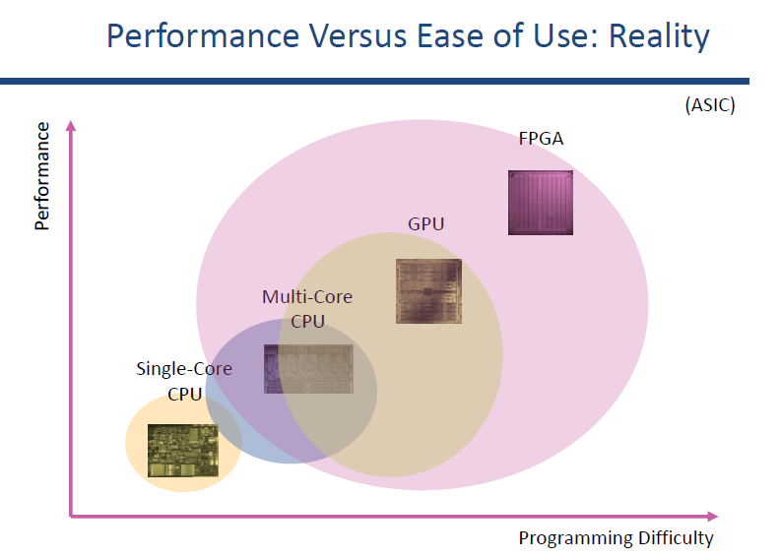

## Why CPUs

* The CPU's flexibility through program (“software”) makes management of the model's parameters a breeze – the model can be stored as an abstract data type with clean methods that are very simple to program (‎2.3.1+‎2.3.4),  
  all the while the operation system manages data and memory behind the scenes.
* The existing arithmetic libraries enable us to focus on the design, and not on the meticulous arithmetic implementation of the complex activation functions (‎2.3.3).
* In addition, the handlers for different data set formats is extremely accessible due to a vast file extension support and open source code for new formats (‎2.3.6)
* Programmers can write the code with ease, in comparison to FPGAs, and debug one step at a time.

## Why Not CPUs

* A great deal of space and energy goes to data movement and ILP management rather than to computation. Meaning we are aiming to inferior performance of our design right from the start (especially when it comes to actual data computation).  
  this is a huge disadvantage for a high-performance design and is enough to discard this method as a standalone means.
* Amdahl’s law points out that adding CPU Cores alone won't suffice if a serial portion of the code is unavoidable (‎2.3.5).
* No innate support for different-then-standard data type sizes (‎2.3.2).

## Why FPGAs

* FPGA are made for efficient spatial computing and massive data parallelism, just like our project's aim for tailoring resources to ANNs.   
  The FPGAs outperform the many-cores CPUs with less power!
* We don't have any “management” overhead, and are free to implement the best physical design:  
  like fastest activation functions (‎2.3.3),  
  or even if it means exotic data type representation (‎2.3.2) that yield best results.

## Why Not FPGAs

* Programing difficulties for programmers, as writing hardware descriptive languages proves to be incredibly hard if we want to fully exploit the configurability:  
  we get no middle-man and must depict each data's validity and timing from each complication logic, and make sure it aligns in time and space with the entire design   
  (No Under-The-Hood codes like the OS services and drivers provided in a CPU).
* Manually mange large movement & storage of the model's parameters and state (‎2.3.1+‎2.3.4).
* Require explicit new format handler for different data set formats (‎2.3.6).

If it doesn't exist, and you get no source code – you must create it.

## FPGA Programing Made Simpler

The ideal platform would be a *Heterogenic Data Flow Hardware System*!   
taking the ease of data traffic and formatting of a CPU,   
combined with the high speed spatial competition of data flow as done in the FPGAs.

There are languages that enable expression of data flow with high-level synthesis tools that are taking C/C++/java simple codes, and generating RTL IPs with built-in libraries created for us by experts. One such is the *Maxeler Platform*

# Maxeler Platform

On this project, we choose to implement a ANN on the Heterogenic Data Flow Hardware System called the "Maxeler" Platform!

## Maxeler Approach and Purpose

Maxeler intends to provide accessible solutions to implementing Massive Data Algorithms in parallel, on a high area and speed programmable hardware architecture, while enabling high-level programing language and programing environment like Java.

The motivation comes from the fact that the physical barriers of serial processing performance do not allow sufficient massive data processing. Making parallel processing a promising direction for empowering performance.

Parallel hardware programming is the most effective way to exploit the modern calculation capabilities, although its implementation is regarded highly complex and difficult.  
The Maxeler platform attempts to bridge the gaps between the two by a fast-parallel implementation made by a convenient and easy programing language descriptions.

The accessibility enables "In House" programmers to execute their own design faster and with fewer resources, less time and less money on a robust high-end platform.

## Maxeler Usage Outline

The outline use of a given Maxeler design will be compiled and burnet on a stationary hardware board stack- interfacing immense data flow or "real-time" analysis.

The programmer must only concentrate on the processing of information algorithms.

In the lab, the "workstation" module serves as both a programming computer equipped with the environment of a Linux OS, and the hardware parallel computing vassal in one.

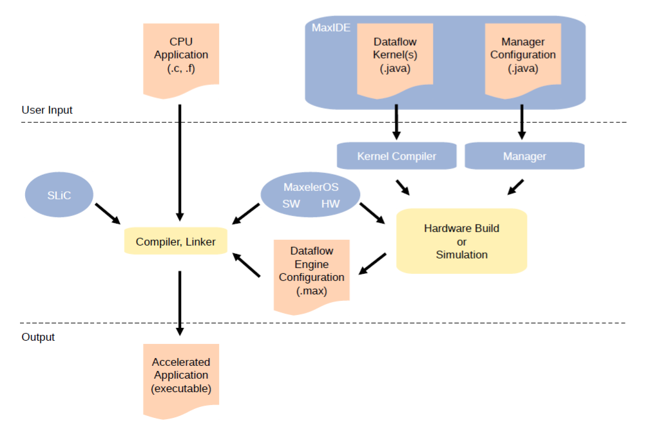

## Maxeler Internal Structure (Maxeler.com, 2011)

The resources in the platform are designed in advance for dense, memory-intensive, fast and high bandwidth designs. Thus, easily avoiding logic cells and memory access pruning.

When it comes to exploiting the fullest of the hardware available while maintaining a possibility of re-configuration at reasonable cost, *‎4.3.4 FPGA* is the most common platform and it is the main computing chip in the Maxeler. The elements comprise the platform are:

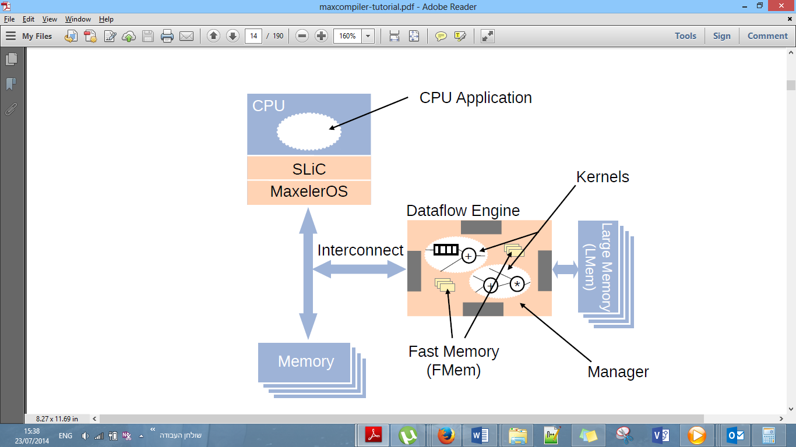

### PATH - Data Flow Engines

The user will divide the functionality they want to implement onto separate computational units called DFE (Data Flow Engine).

All these units will be translated into hardware (internal partition to several FPGAs).

The architectural topology of many such DFE units across the hardware will determine the final algorithm desired.

The description of any single DFE are separated into two parts:

1. Kernel(s for there may be more the one)
2. Manager

In detail:

#### Kernel: *Functional* *Unit*

Kernels are graphs of pipelined arithmetic units implementing a computation depicting the actions on the inputs and their effect on the calculate output.

"Java" is the programing language for the Kernel.

The main functionality will be in kernels defying core actions like sum, div, select spatial vector window, sort and get median etc….

#### Manager: *Connection* *Topology* *and State Machines*

The Manager orchestrates data movement within the DFE like how to connect more than one kernel, and packing into a single unit that performs a specific function. Manager can perform FSM control over data paths connecting different memories, data buses and outputs as needed.

"Java" is the programing language for the Manager.

Within the manager we can call and connect 2 different types of memories and various available interconnects depending on the specific dataflow machine.

Thus, we concluded the two main part of the DFE (Data Flow Engine).

### CONTROL- Main Processor/CPU Host

We need external control to take care over the input data stream, driving it to the appropriate interfaces buses and DFEs, in the desired order to make the output stream required.

This description of our algorithm would be done by a Main processor platform.

The CPU Host oversees executing instruction written by the programmer by witch it manages the passing of data streams to certain DFEs in certain order.

"C/C++" is the programing language for the CPU.

The Maxeler environment generates dataflow implementations which can then be called from the CPU via the SLiC interface. The SLiC (Simple Live CPU) interface is an automatically generated interface to the dataflow program, making it easy to call dataflow engines from attached CPUs.

The overall system is managed by MaxelerOS, which sits within Linux and also within the Dataflow Engine’s manager.   
MaxelerOS manages data transfer and dynamic optimization at runtime.

# Design Considerations

## Problem Statement & Addressing the Challenges

The challenges presented in chapter ‎2.3 are making it hard for developers and users to get accessible ANN frameworks with DEDICATED platform for ANNs.

* We cannot prune the sheer number of ANN's modules parameters, for this would damage the theoretical correctness of the mathematical model- hence we must enable flexibility each parameter (‎2.3.1).
  + favoring CPUs
* We do want to enable Data Type Precision with as much control as possible, if only because the potential of optimizing this degree of freedom is a hot topic that can greatly reduce area and logic use while retaining same performances (‎2.3.2).
  + favoring FPGAs
* We do want to compute the neural activation function as optimized as possible, because ANN with non-linear activation function is key for applying machine learning into new fields, so higher speed in core calculation is of upmost importance (‎2.3.3).
  + favoring FPGAs
* There is no escaping from saving ANN temporary state to keep the correctness of the mathematical model (‎2.3.4)– so storing only the valid registers needed for the backpropagation is the minimalist way of approaching this challenge.   
  Though using GDT containers is easier, close memory like cache or even register-based will suffice.
* We cannot achieve any high speed performance when just pass a single data entry, wait for it to pass and finish feedforward, and the do a backpropagation and correct the ANNs parameters, and only then insert a new data entry.  
  So we want to apply parallel computing, but there is an intricately when choosing to implement an ANN when data passes through the models as parameters of weights and biases are changing – because the backpropagation will require of us to save the different values of the parameters per data per interaction – a price to heavy on the memory and computation of the model.  
  We will use Batch Updating instead – letting multiple data entries pass with same module parameters, before averaging their contribution to the overall correction and applying it via backpropagation. (‎2.3.5)
  + this opens our design up to a pipeline as the preferred method, provided we have enough space resources.
  + If we do not have enough space resources, a fast spatial-scheduler-like method is best method, but this is only after we knew concurrent design is over the available area – and beyond the scope of this project
* We do want to enable as much data set formats with the most convenient API that will give users ability to insert their own pre & post process stages, knowing ANN are widely used (‎2.3.6). Having a rigid ANN will not enable user to use out solution.
  + favoring CPUs

## Overview of Existing Solutions

### Not Using Deep Learning Software Libraries

Most of the popular deep learning libraries have interface for Python, followed by Lua, Java and Matlab like: Caffe, DeepLearning4j, TensorFlow, Theano and Torch.

TensorFlow, for example, an open source software library for numerical computation using DataFlow graphs (as explained in section ‎4.3.1). Nodes in the graph represent mathematical operations, while graph edges represent multi-dimensional data arrays (aka tensors) communicated between them. The flexible architecture allows you to deploy computation to one or more CPUs or GPUs in a desktop, server, or mobile device with a single API.   
Meaning it’s a code library performing Single Instruction on Multiple Data at most when using GPUs instead of CPU\s.

Those method enables parallel computing and even distributed computing over many CPUs, and shows fast results when data set is large enough.   
  
But we dropped those solutions, Given the fact that arithmetic calculation is done by a general purposed CPU – **and it is far more inferior when compared to dedicated hardware integrated circuits** (overheads from the machine level like generic multi-purpose ALU, data dependencies, cache utilization, and OS management).

### Not Using FPGAs Explosively

This train of thought will properly outperform any other implementation:   
FPGA based reconfigurable computing architectures are well-suited to implement ANNs as one can exploit the concurrency and rapidly reconfigure to adapt the weights and topologies of an ANN.

But integration and data traffic management will deem too complex and rigid for developers. Not to mention that adding pre/post pressing stages will be hard to program and won't be dynamically added with ease.

The sheer complexity of an overall FPGA system is beyond the scope of this project, and the fact that there are no easily found HDL source codes leads this solution irrelevant.

## Leading to the Best Design

Our main thinking behind the design, is that we can use both FPGAs and CPUs together:  
*use task division for a heterogenic dataflow system on each platform's best side only*.   
(not fully implement the system only of FPGAs or only on CPU).

* The heavy ANN's core calculations of Feedforward and Backpropagations can be implemented over FPGAs. Thereby exploiting the concurrency of ANNs via a computational logic pipeline for a complete parallel spatial structure of a stream dataflow engine.
* The orchestration of data movement and pre/post processing could be done by a CPU -managing and scheduling the entire ANN phases.

# Proposed Solution

Field Programmable Gate Array (FPGA) based reconfigurable computing architectures are well-suited to implement ANNs as one can exploit the concurrency and rapidly reconfigure to adapt the weights and topologies of an ANN.

But data traffic overheads and management will deem too price for developers. Not to mention that adding pre/post pressing stages will be hard to program and won't be dynamically added with ease.

Thus, we shall combine a **heterogeneous system**: a CPU to handle data traffics to/from the hardware ANN.

Luckily, Maxeler Platform's approach fully epitomizes this endeavor! enabling complete development in both a strong multi-core Host CPU, and an array of FPGA kernels.

The we can achieve a maximum performance ANN framework. None of which is available today!

## Concept

### Our Goals: Plan a Fully Connected ANN Hardware Generic Building Blocks and Implement it over the Maxeler



With the following on mind:

* Parallel Data Flow Engines ANN in Hardware
* Creating a Generic Building Block for AI architectures
  + Supporting Pre\Post data analysis or feature extractions
  + different activation functions
* Generic AI API
  + Loading and Exporting AI parameters for different tasks
  + Controlling Database partition and Epoch sizes
* CPU Controller oversees training and outputting
  + C++ Host Code calls the ANN
* Comprehensive Statistical Learning Report on ANN

## Architecture

the fundamental structures of our system and the discipline of creating such structures are as follows:

### Tasks Division

Each structure comprises of architecture elements and their unique task. We divided the task based on what parts would be a fit to the software, and hardware.

#### CPU HOST

The CPU host will orchestrate the entire ANN phases, and will take care of data preparation and movement around the core ANN calculation that is done in the DFE hardware:

* + API wrapper
  + Database management
  + DFE configuration for ANN architectural structure
  + Models Update per training epoch
  + Calculated Statistical Errors per epoch
  + Logger

#### Maxeler DFE Hardware

The Fully Connected ANN's core calculations (Feedforward and Backpropagations) will be planed and implemented over hardware, as a complete parallel spatial structure of a stream Dataflow Engine.

* + Fully connected nets
  + Feedforward Parallel Data Stream Engine
  + Backpropagation of weights and biases
  + Output shaping and clamping

A single call of the DFE will train and learn over 1 data set Epoch!

### Communications between Elements

#### User ↔ Maxeler ANN BlackBox

User will supply the Data Set in the projects work directory, and will configure and write the wanted Global Parameters before running the program.

#### CPU HOST ↔ DFE Hardware

Maxeler's built in SLiC interface will automatically connect these parts.

#### Kernels between Kernels

A single "CustomManager" was written to connect the kernels according to the user's API and Parameters.

# Implementation Overview

## Environment

In our Parallel Systems Laboratory, we use workstation module that serves as both a programmer's computer with all platform environment included in a Linux OS, and the hardware parallel computing vassal in one.

## Application Usage Flow

The user sees the complete system as a C++ CPU Host function.   
The abstraction of the design will allow us to wrap the entire system "Under the Hood".

### User API and Parameters

#### Input Train and Test Sets

* The user will place .CSV files in the followed location:  
  *<ProjectWorkspace >/ CPUCode*
* Each new data entry will be in a new line.
* The single-entry vector values will be separated via a comma character ','
* The 'training_set.csv' and 'training_class.csv' will describe the training set's input to the ANN, and its desired expected output, correspondingly in that order – on which the learning will take place.
* The 'testing_set.csv' and 'testing_class.csv' will describe the test set's input to the ANN, and its desired expected output, correspondingly in that order – for performance analysis.

#### Fully Connected ANN Parameters

We use 2 header files for the defines of our solution:

* *<ProjectWorkspace >/EngineCode/src/dualkernel/global_header.maxj* 
  + This is the DFE Hardware parameters used to:
    - construct the topology of the ANN, (layers size)
    - neural activation function
    - data float precision representation
    - epoch size of Batch update
  + will not change unless we want different net size.
* *<ProjectWorkspace >/CPUCode/Header.h* 
  + This is the CPU Host parameters used to:
    - learning rate
    - enable logger modes
    - debug vectors per step
    - initial condition of weights & biases
    - enable stochastic data order shuffling
    - output layer Clamping and Rounding
  + Depending on these parameters, the same run might converge into different results.

## Application Layer

Here is the main flow of our solution and what component is executing it:



### CPU Load DataBase & Initialize ANN Model

The CPU will load all user inputted data and parameters. Afterwards it will allocating the data streams and load ANN topology. This happens only once in the beginning of the program.

**Important note:** the Maxeler streaming interface demands that the CPU will pass a string argument that depicts the splitting and fanning stream that go inside the DFE manager. We had worked hard to create a simple initial function called "create_routing_string" that does just that based solely on the ANN parameters.

Also, given the c++ libs in use in the Maxeler OS, we implemented a wrapper for generating a standard normal distribution array (called "standardNormalDistributionArray")

### DFE Feedforward & Backpropagation of the Fully Connected ANN of 1 Epoch



#### Driving the input data from CPU into ANN input layer of an entire Epoch Per DFE Call

The CPU will utilize the Maxeler SliC interface and will push a new data set entry to the DFE hardware pipeline, until the Epoch done – so we call the DFE per Epoch.

We wanted to utilize the hardware pipeline, thus making Batch Epoch Update the idle method of weights and bias update.   
This is because any update of those created a feedback loop that renders the data inside the pipeline obsolete. So, by working only per Batch Epoch we ensured we average the gradient change no nullify noise, and at the same time taking enough data samples before stopping the entire net for learning corrections.

The expected (desired) class\target values of each data entry is also pushed into the DFE from the CPU. It passes through the pipeline stages until the ANN Feedforward is done and it can be compared to what the ANN had computed.

#### Feedforward single layer: Connectivity Band Kernel

This DFE Hardware Kernel named "connectivity_band_Kernel.maxj" implements a Fully Connected network that connects each point in the output of the previous layer, to this layer activation function by multiplying the data with the current layers weights and bias



The implementation of the Matrix Multifaction was done by a Loop-Unrolling Pipelined method to achieve minimal latency and computational complicity while using the bare minimal LUTs and resources.

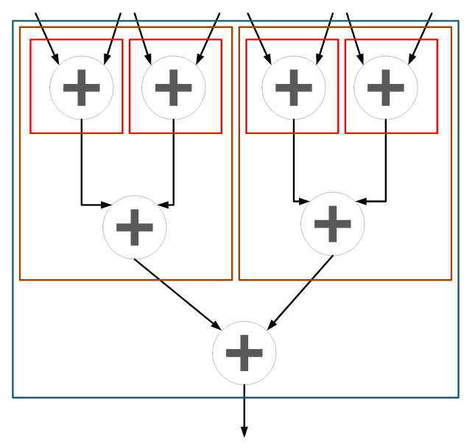

#### Feedforward single layer: Neuron Activation Function Kernel

This DFE Hardware Kernel named "neuron_activation_function_kernel.maxj" implements a vector wise activation function after previous module (‎5.3.2.2).

If we were to change this module calculation, we must make sure the derivative also changes with respect to the activation function (‎5.3.2.5).

here in the visoi is an example of Sigmond function:



**Important note**: the Maxeler math library that implements exponential power (KernelMath.exp) had NOT implemented the correct calculation when the input was a Float type SADLY! We had shown that casting the Float into the nears Integer dose not hurt performances and insert only a minute margin of error.

**The last 2 kernels (**‎5.3.2.2 + ‎5.3.2.3**) combined are calculating a Single layer in the ANN. Depending on the parameters we would use as many instances (and vector width) of these two until every layer has a kernel**. Thus, concluding our Feedforward stream.

#### ANN Error Kernel

This DFE Hardware Kernel named "FF_net_error_Kernel.maxj" implements a vector wise

calculation of final ANN Output Layer's total Error in respect to the target expected values supplied by the user.

i.e., this module is used only once, as the first step of the Back Propagation

after the last neuron_activation_function.

The Lost Function is SSE: 

The expected (desired) class\target expected values of each data entry is now popped from the pipeline stream, so that the output net from input at time T, corresponds and compared to the expected target at time T.



#### Back Propagation single layer: Neuron Activation Derivative Function Kernel

This DFE Hardware Kernel named "neuron_activation_function_div_kernel.maxj" implements a vector wise activation function derivative calculation to be used in the Gradient Descent algorithm.

If we were to change this module calculation, we must make sure the actual original activation function (‎5.3.2.3) also changes with respect to the derivative.

here in the visoi is an example of Sigmond function: 

#### Back Propagation single layer: Back Propagation Kernel

This DFE Hardware Kernel named "Back_propagation_kernel.maxj" implements a vector wise calculation of layer's error. to be used in the Gradient Descent algorithm.



#### Back Propagation single layer: Back Propagation Connectivity Band Kernel

This DFE Hardware Kernel named "BP_connectivity_band_Kernel.maxj" implements the calculation of correction of weights & bias based on the error – that will minimize the cost function via the gradient descent algorithm, and summarize the correction until epoch batch end. Only then will we update weights & biases, i.e. with a DFE Loopback!



**The last 2 kernels (**‎5.3.2.6+**‎**5.3.2.7**) combined are calculating a Single layer in the ANN. Depending on the parameters we would use as many instances (and vector width) of these two until every layer has a kernel**. Thus, concluding our Back-Propagation stream.

#### SoftMax Kernel

This DFE Hardware Kernel named "softmax_kernel.maxj" implements a vector wise SoftMax activation for the output layer of a stochastic net where we desire to output to be a probabilistic representation of classes.

#### Vector Duplicate Kernel

This DFE Hardware helper Kernel named "vector_dup_Kernel.maxj" is used to hold same value in different stages in the hardware pipeline.

### Non Blocking CPU prepare next Epoch & Statistics

As shown in this following dependency graph, we can achieve parallelism by preparing the next iteration Epoch data in the CPU: permutation the entries order,   
and calculation last Epoch performance statistics by the CPU Host,   
while at the same time the Hardware DFE is working on the current Epoch.



This will be done by a Non-Blocking call to the DFE.

#### CPU permutationOnPairOfArray

This c++ function helps to shuffle the data of both the input entries and target output entries to a random permutation. This function runs aids by decrease overfitting on fixed data sequences.

#### CPU doStatistics

This c++ analysis function calculates last Epoch performances and saves them to a log if enabled:

* accuracy
* epoch MSE
* class confusion matrix

#### CPU doUpdateModelAfterDFE

This c++ function updated the next Epoch ANN weights and biases using the learning rate and the batched averaged DFE weights and biases correction.

Making this function a barrier that can only be called after entire epoch is ran through the DFE, and before next epoch.

#### CPU check

A debug only c++ function that compares DFE ANN return output layer to a given Matlab ANN with the same data, weights and biases.

compares floats via epsilon margin.

#### CPU clampToBinaryOutput

This c++ function is used to binarize a NetVariableType using bottom and upper thresholds. This is useful when output is a binary vector.

### CPU Stop condition & save ANN Model

The final ANN is stored by the weights as biases, thus exporting them will save the ANN.

# Development Process

## Development Methodologies

The project was divided into subtasks and steps shown in our Ghent:

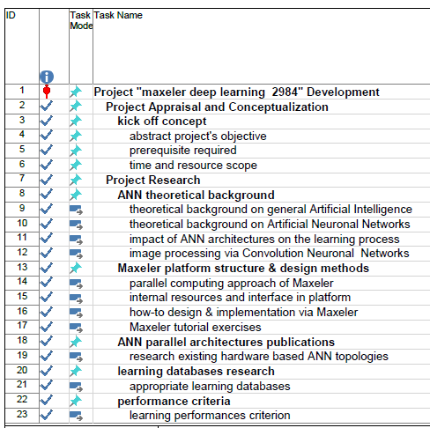

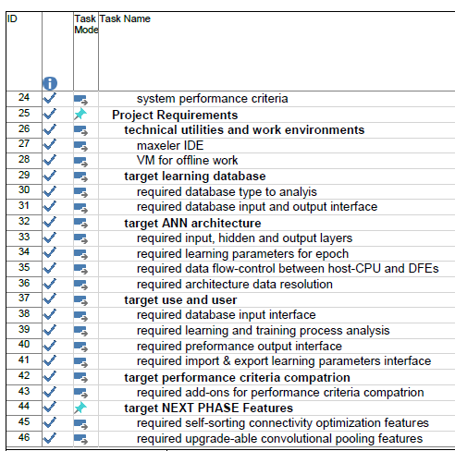

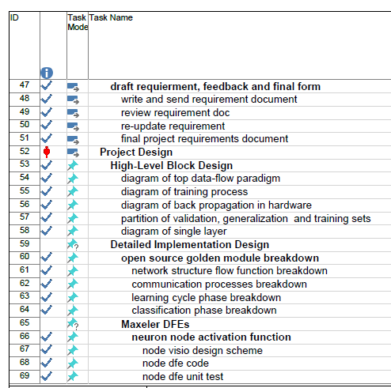

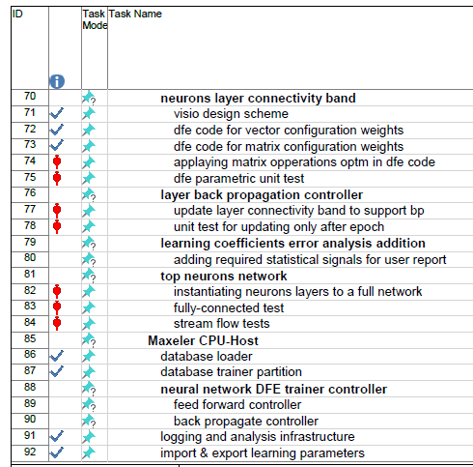

## Design Patterns

1. Upon completion of catching up to the theoretical background of ANN,  
   we went over many cycles of devising the computational tasks between the DFE and CPU, and the full DFE architecture and Building Blocks [that were explained in chapter ‎5.3.2].
2. We implemented a Matlab Golden Module to apply our abstract algorithm – so that we would check if it converges to a desired accuracy, and plot understandable results.
3. Only after the entire completion of the full DFE architecture, we moved on to the planning and design of the inner modules – **in the spirit of Top to Bottom**!
4. Only then for each of our building blocks we:
   * Implement the DFE Kernel
   * Create a unit DFE Manager
   * Use the Golden Model and CPU Host to inject meaningful data and expected result after the DFE Kernal
   * Compare **Simulation** result and fix :)
5. Full DFE Manager for the entire ANN integration.
6. Expending the CPU Host code for added user interface and helper function
7. Run full **Simulation** of the ANN
8. Run full **Synthesized Hardware Test** of the ANN

# Testing

## Simulation Unit Testing

Following the discussion in the previous chapter, we were driven by the need to always compare each module's actions to the corresponding Golden Module outcome.

We had relayed heavily on the Maxeler vector kernels examples as the bases of syntax needed to translate our algorithm to a proper DFE. This enabled us to meticulously zoom in on bugs and feathers.

* Our main difficulty was upon new unfamiliar Maxeler syntax and cases where the supplied tutorials had not generalized the use of what showcased, of insufficient error messages about data width and sizes used to transfer it from\to the CPU.
* Another challenge was the "BP_connectivity_band_Kernel" [chapter ‎5.3.2.7]. This was the only place inside our DFE Hardware in which a pipeline feedback loop was unavoidable given the need to sum up the Epoch batch updates.   
  This would require 2 auto-compilations of the kernel. One for finding out the pipeline loop length and the other for final nodes and register location's rank. All the while maintaining control the data validity flow of pushing and popping new valid data at the right clock tick.

A big disadvantage to unit test is the fact that the CPU Host and Manager are hiding any data stream halts and validity propagation timing within the data in the pipeline, hence the next step after the logical behavior was verified, was the integration of kernels.

## Simulation Integration Testing

As a pre-condition, we had to overcame the problems of creating a parameter-defined flexible Fully Connected ANN Manager that will instance and connect each of DFE Kernel with the appropriate inputs and output sizes and widths. This means we now held the final ANN DFE Manager – depicting the ANN topology architecture based on the parameters.

Then we started the actual simulated integration of the full ANN, but ran into issues of data stream valid WaveFront – i.e. the data from different inner streams was not aligned to the same data in other streams passing through different logics.

The Infamous Stream Halt can be witnessed in the leftmost diagram below.

We solved this matter by mathematically defining per stream the number of valid data entries that will be popped and pushed inside the DFE Manager – depending on the ANN and DFEvar parameters. Thereby aligning the data from the same entry plane in the architecture's streams. The valid stream result can be shown in the rightmost diagram below.

After this stage was done, our Maxeler Simulation and the Golden Model were preforming the same calculation, given the same data and initial conditions!

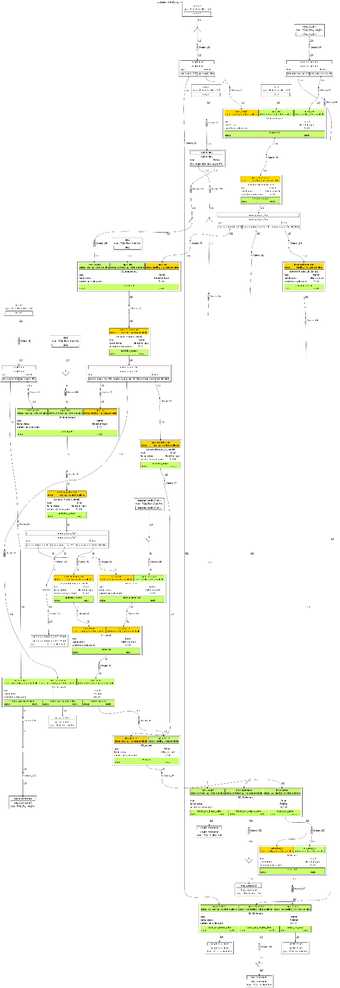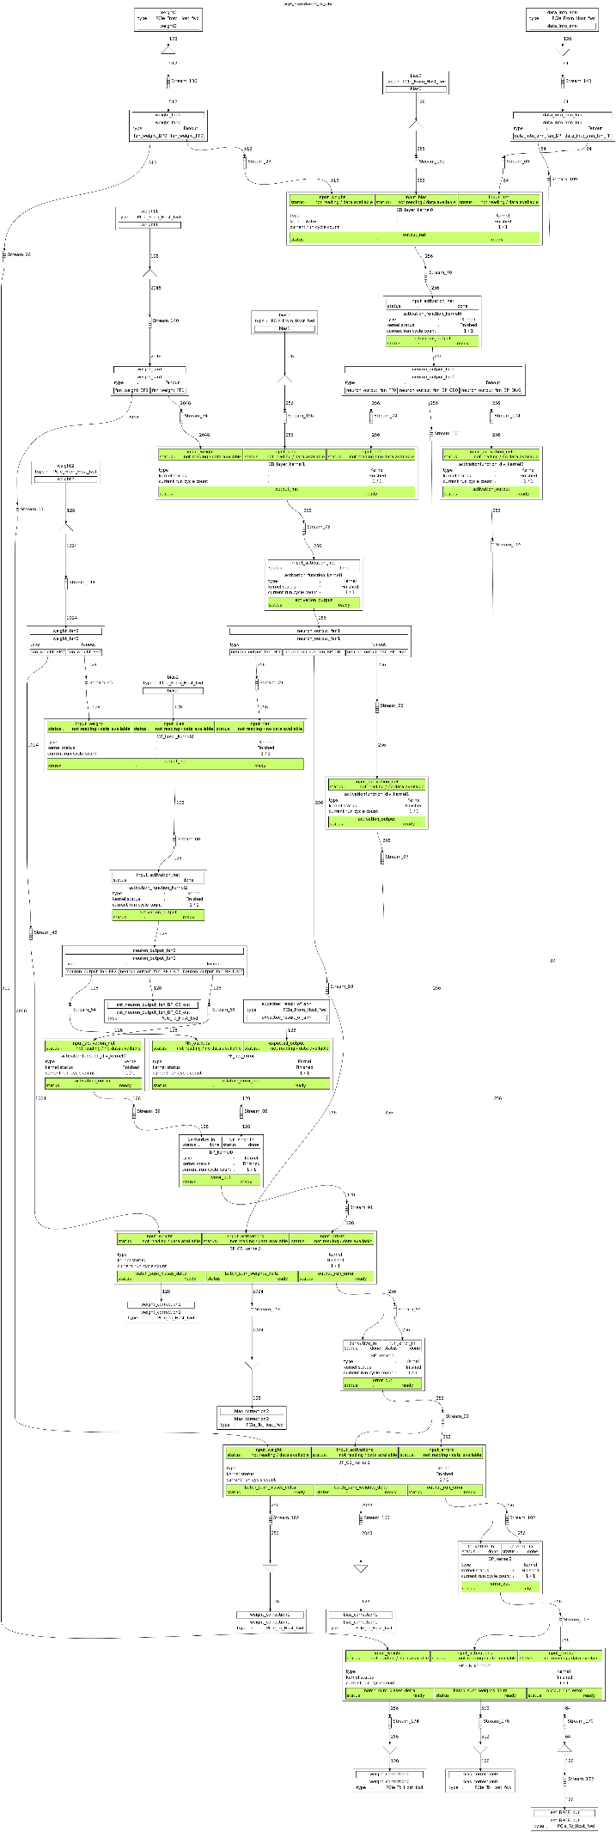

## Functional Synthesized Hardware Testing

The next step after logical simulation of the DFE Hardware is to synthesize the design into the FPGAs in the Maxeler.   
The resulting burning file is the final ANN that will run on the hardware.

We use the same exact simulation test bench to assure the physical computation is the same as the simulated.

Initially we got zeroes on the ANN output and after some investigating we had discovered that the source is in the "neuron_activation_function_kernel.maxj" activation function: the KernalMath.exp float argument representation in the Maxeler math library that implements exponential power (KernelMath.exp) had NOT implemented the correct calculation when the input was a Float type SADLY!   
This issue was not noticed beforehand because the simulation values differ from actual hardware results!  
We had shown that casting the Float into the nears Integer dose not hurt performances and insert only a minute margin of error.

After this stage was done, our Maxeler Hardware and the Golden Model were preforming the same calculation, given the same data and initial conditions!

## Performance Testing (Kelleher, 2013)

We used 2 main date sets:

* Center for Machine Learning and Intelligent Systems: Letter Recognition Data Set
* Self-generated N-Dimensional Gaussian noised clusters classes 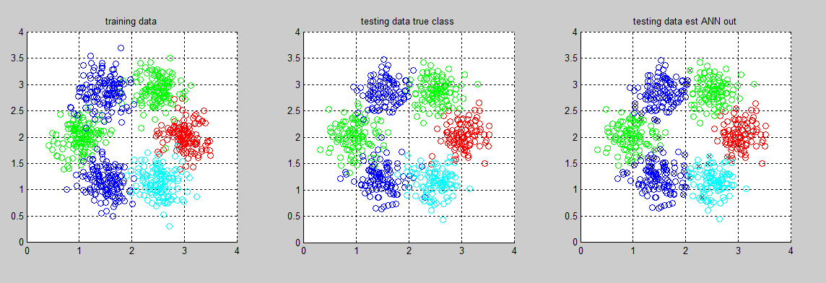

### Resource Utilization

The ANN took a lot of resources from the overall area – effecting the scalability of our project. See next chapter for future work.

The synthesis was performed on a single Xilinx Spartan 6 FPGA board.

ANN = [2 8 4] RESOURCE USAGE

* Logic utilization: 195599 / 297600 (65.73%)
* LUTs: 140452 / 297600 (47.19%)
* Primary FFs: 187653 / 297600 (63.06%)
* Multipliers (25x18): 444 / 2016 (22.02%)
* DSP blocks: 444 / 2016 (22.02%)
* Block memory (BRAM18): 377 / 2128 (17.72%)

ANN = [2 8 8 4] RESOURCE USAGE

* Logic utilization: 388378 / 297600 (130.50%)
* LUTs: 281913 / 297600 (94.73%)
* Primary FFs: 377632 / 297600 (126.89%)
* Multipliers (25x18): 932 / 2016 (46.23%)
* DSP blocks: 932 / 2016 (46.23%)
* Block memory (BRAM18): 718 / 2128 (33.74%)

As seen from the tables above, an addition of a single eight neurons hidden layer made the design exceed the logic and FFs utilization.

The lack of logic seems to come from the fully connected net topology that require a lot of flip flops and logics, second after is the LUTs usage caused by the 32-bit float exponent and $e^{x}$ calculations.

Since the ANN we managed to synthesize is very small we see this as a “proof of concept” and did not compare the performance against other systems.

### Accuracy

Here are the accuracy performance of the Maxeler ANN:









 

# An "HOW TO" Guide

## Build & Run Golden Model

This Step is optimal and help us immensely when first creating the project. As long as there are *.csv of both train and test.

To use our matlab golden model to create the above stated file and more:

1. Copy the entire folder Final Report/ANN_SourceCodes/Matlab_Golden_Model  
   (link <https://1drv.ms/f/s!AnS8O9QrD81Mk1nGZpOq3d9EkhQn> )  
   into your Workspace/Matlab_Golden_Model and enter this new path.
2. Choose any desired Data Set in a *.csv format of 2 files:  
   <ANN Input Data>.csv  
   <ANN Target Output>.csv   
   in Final Report/ANN_SourceCodes/Matlab_Golden_Model/csv files  
   we have an example of a MINST a letter Data Set.  
   More Data Sets that we used are in:  
   Final Report/ANN_SourceCodes/DataSets  
   (link: <https://1drv.ms/f/s!AnS8O9QrD81Mk1Uf_dPQgJcj-wqE> )
3. Open "run_mlp.m" in Matlab
4. Configure the ANN Golden Model via the following parameters:

|  |  |  |  |
| --- | --- | --- | --- |
| Line in "run_mlp.m" | Variable name | How To use | Example of value |
| 34 | hidden_layers | the number of neurons in the input & output layers are fixed when a Data Set csv file is loaded.  we can control the number of neurons in each hidden layer by writing them in a new element in this vector. | [4 8] # means 4 neurons in the first hidden layer, and 8 neuron in the second (and last) hidden layer. |
| 35 | iterations | Iterations limit. | 1500 # is fine |
| 36 | learning_rate | gradient descent learning rate algorithm | 1 # is fine |
| 39 | batch_mode_update | {0,1} a flag for the method of model's weights per data entry: 0: update net once per data entry.  1: update once in <epoch_size> entries by averaging. | 1 # we use batch update mode to maximize DFE pipeline use |
| 40 | epoch_size | Number of data elements for batch update. | 128 # is fine |
| 42 | load_model_from_file | {0,1} a flag for loading an existing ANN model: 0: start weights at random.  1: load weights from "model.mat" | 0 # for new random weights each run. |
| 44 | disable_export | {0,1} a flag for exporting detailed calculations value during ANN train for complete comparison as a: " csv files/*.csv" format.  when dramatically changing DFE and wanting to compare it to golden model its useful. 0: save log per iteration.  1: don’t export debug log. | 1# when we don’t need to compare every middle calc.  0# when dramatically changing DFE |
| 46 | actietion_func_sel | { 'sigmond' , 'INT sigmond' , 'ReLU' , 'Leaky ReLU' , 'SoftMax' , 'SoftMax INT' } to control the neuronal activation function | 'INT sigmond' # like the DFE in the Maxeler |
| 47 | use_softmax_for _final_layer | {0,1} a flag for using softmax stochastic layer only in output layer: 0: use regular activation function  1: use softmax | 0 # use regular output layer. |

1. Run "run_mlp.m" in Matlab. *The code currently generates 2D input data classified into 4 classes when running into the following *.csv files*:   
   'csv files/training_set.csv' , 'csv files/training_class.csv',...  
    'csv files/testing_set.csv' , 'csv files/testing_class.csv',...   
   these files will the same input and target data for our DFE model!
2. The following *.csv files are also created to depict initial ANN condition:  
   'csv files/initial_model_weights.csv', 'csv files/initial_model_biases.csv',...
3. If (disable_export==0) we also have per iteration logs:  
   'csv files/CB.csv': ANN's connectivity bands of each layer  
   'csv files/activations.csv': each neuron output per iteration  
   'csv files/mirror_BP.csv': each layer back propagation in revered order  
   'csv files/mirror_BP_CB.csv': ANN's back propagation connective bands of each layer  
   'csv files/new_model_weights.csv': new ANN weights after each update  
   'csv files/new_model_biases.csv': new ANN biases after each update

## Import DFE Project

If a DFE of our project isn’t open in your workspace, please do the following:

1. Return back to main Workspace
2. Copy the entire folder Final Report/ANN_SourceCodes/DFE_sourcecode   
   (link <https://1drv.ms/f/s!AnS8O9QrD81Mk1f4JXMLtRWgdim8> )  
   into your Workspace/DFE_sourcecode .
3. To launch MaxIDE, enter the command 'maxide' at a shell command prompt.
4. Import the project source code into MaxIDE:   
   Click on Auto-import MaxCompiler tutorial projects on the welcome page. 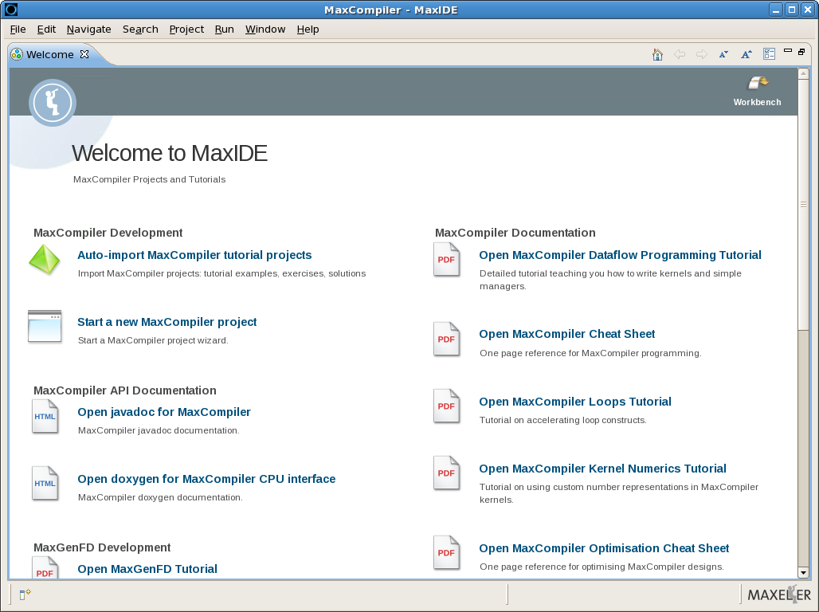  
   This brings up the import wizard.  
   Click on the Finish button to import the source code and all supporting material for your selections of Workspace/DFE_sourcecode.
5. When the import is complete, MaxIDE switches to the MaxCompiler Project perspective. The Project Explorer panel on the left has a heading for each of the projects you imported.

## Prepare DFE Setting Before Build

This step is mandatory to configure ANN before DFE Synthesis:

1. Each project can be expanded to show the three subheadings of CPU Code, Engine Code, and Run Rules.  
   Navigating further below the CPU Code or Engine Code headings leads to individual C++, or MaxJ source code files that you can open for editing.
2. Open "EngineCode/src/dualkernel/global_header.maxj" and Configure the ANN parameters **just like** the Golden Model via the following parameters:

|  |  |  |  |
| --- | --- | --- | --- |
| Line in " global_header.maxj" | Variable name | How To use | Example of value |
| 15 | HIDDEN_LAYERS_NEURONS | number of neurons in EACH single Hidden Layer (same sized hidden). | 8; // 8 neuron every hidden layer. |
| 16 | N_INPUTS | number of neurons in the Input Layer | 2; |
| 17 | N_OUTPUTS | number of neurons in the Output Layer | 4; |
| 18 | NUM_OF_HIDDEN_LAYERS | total number of fully connected Hidden Layer | 1; |
| 20 | exponent | Neuron_Type float bit representation of exponent | 8; |
| 21 | significand | Neuron_Type float bit representation of mantica | 24; |
| 25 | EPOCH_SIZE | Number of data elements for batch update. | 128; |
| 29 | en_debug_print | {false,true} a flag for using DFE simulation debug prints. | false; |
| 44 | activation_function_div | internal Neuron activation function derivative calc code. | input_net* (1-input_net); |

1. make sure that " EngineCode/src/dualkernel/neuron_activation_function_kernel.maxj" implements the desired activation function.
2. Open "CPUCode/Header.h" and Configure the ANN parameters **just like** the Golden Model via the following parameters:

|  |  |  |  |
| --- | --- | --- | --- |
| Line in " Header.h" | Variable name | How To use | Example of value |
| 17 | RAND_INIT_WIGHTS | If true will randomize ANN weights and biases from a Standard Normal Distribution.  If false will load initial ANN from: "initial_model_weights.csv"  "initial_model_biases.csv" | (ture) // if we are not loading a pre-working ANN |
| 18 | RAND_SET_PREMUTATION_ ONLY_AT_END_OF_SET | If true, will only shuffle Set after it has been fully used and about to be re-used.  If false, will always shuffle next epoch block in Set | (false) |
| 19 | PLOT_EPOCH_LOG_ACTIVETY | If true CPU will print progress debug notes | (false) |
| 20 | CMP_TO_RESULT_FROM_MATLAB | If true, will not shuffle Data Set, and instead will compare DFE result to Golden model's saved log using  "activations.csv"  "new_model_weights.csv"  "new_model_biases.csv" if false, will not compare between epochs. | (false) |
| 21 | PLOT_ANN_OUTPUT | If true, will print a matrix of epoch's ANN output vs expected result of ANN | (false) |
| 22 | PLOT_DEBUG_MATRIX | If true, will print a ANN parameters weights and biases matrix of epoch | (false) |
| 23 | DO_STATISTICS | If true, will save accuracy to "AccuracyLogFile.txt" and will calc confusion_matrix | (true) |
| 24 | PLOT_STATISTICS | If true, will plot the mentioned above statistics during the DFE run. | (false) |
| 26 | CLAP_ANN_OUT_TO_BINARY | If true, will use thresholds to make ANN's output a binary one. | (false) |
| 27 | CLAP_MAX_VALUE_FOR_0 |  | (0.25) |
| 28 | CLAP_MIN_VALUE_FOR_1 |  | (0.75) |
| 32 | NUM_OF_EPOCHS_IN_SET | The number of full epochs in training set. |  |
| 33 | REDO_SET_TIME | The number of time we will re-use the data set in training loop |  |
| 34 | CORRECTION_LEARNING_RATE | gradient descent learning rate algorithm | (1) |

1. Notice EPSILON parameter is used for float comparison in "CPUCode/DualKernelCpuCode.cpp" line 50
2. Now our DFE configurations match our golden model settings.
3. Make sure the DFE run rules are set according to your Maxeler device and desired action of either Simulation or Synthesis for an actual hardware run.

## Build & Run & Compare DFE

You can build and run projects using the buttons in the toolbar at the top of MaxIDE. 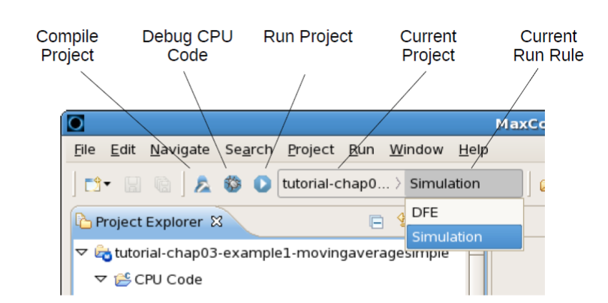

You can select a project and run rule combination using the drop-down boxes, then click one of the buttons to build or run it. The buttons perform the following actions:

1. Build either a simulation or DFE .max file, depending on the selected run rule.

2. This step differs for each of the buttons:

Compile Project - compiles the CPU source code.

Debug CPU Code - builds and runs the CPU source code in debug mode,

where you can step through the CPU code.

Run Project - builds and runs the CPU source code in release mode.

Alternatively, a run rule can be built or run by right-clicking on it in the Project Explorer and selecting either Build, Debug or Run.

## Result Plot

We have several methods of comparing and ANN to Golden Model's *.csv via the CPU parameters.

Now here is an example of visualizing of the ANN result using the CPU report of ANN AccuracyLogFile.txt and a Matlab script.

1. Return back to main Workspace
2. Copy the entire folder Final Report/ANN_SourceCodes/Matlab_Accuracy_Plotter  
   (link <https://1drv.ms/f/s!AnS8O9QrD81Mk1hxobziVEeNKqGz> )  
   into your Workspace/ Matlab_Accuracy_Plotter.
3. Open "accu_test.m" in matlab – it is only an example of how we loaded accuracy vectors and plotted them with a corresponding compression like Learning Rate etc..
4. Adapt the titles as you see fit by this example.

# Future Work

## Performance Optimizations (Zhang, 2015)

The main problem of this topology is the ANN size we managed to create on the current Maxeler system, here we will introduce a few ways to improve (manly enlarge) the size of the ANN that can be synthesize.

### Bigger Better FPGA

Since the current system uses relatively old Xilinx Spartan 6 FPGA that can be swapped with a newer and bigger FPGA.

The following table (Xilinx, 2011) summarize the Xilinx Spartan 6 family features:

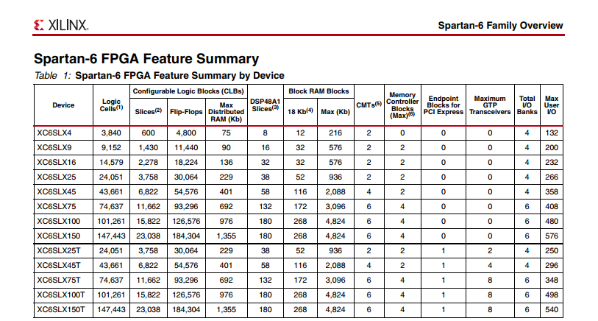

As a comparison, the next table (Xilinx, 2017) shows Xilinx UltraScale family feature summary, that they recommend for machine learning purposes.

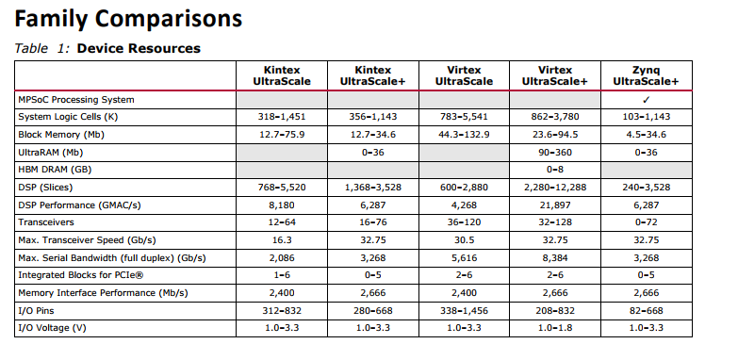

As you can see even the largest Spartan 6 FPGA has a fraction of the gates the smallest UltraScale can offer.

### Reducing Bit representation

In our current design, we use the standard 8,24-bit Float representation, most FPGA ANN based designs optimize the bit representation to fit their desired accuracy, this can reduce the representation of weights, bias and data bit count to 8-bit or even binary one bit which can minimize the LUTs and FFs utilization.

As a first step, we introduced in our design global variables that control the Float bit representation.

### Maxeler Ring – Usage of multiple FPGA

Maxeler has an interface called RING which allows several FPGA to communicate, this allows the ANN design to be shared along a few FPGAs, Maxeler biggest pc includes eight FPGAs on a single bus.

### Thinner Topology

Most ANN topologies are not implemented as fully connected especially the larger networks. instead a random connectivity matrix with minimum number of connections as a restrain is generated for each layer.

This topology allows a reduction in calculation while keeping a decent accuracy.

### GPU link Topology

GPU architecture enable it to construct the same operation on different parts of its memory, this allows the GPU to calculate all the operations needed for one layer of the ANN at a time.

A similar topology can be written for the Maxeler system by creating an accelerator optimized to calculated one layer at a time and push/pop the data from RAM we can achieve a similar setup to that of a GPU.

# Bibliography

(2011, February 27). Retrieved from Maxeler.com: https://www.maxeler.com/media/documents/MaxelerWhitePaperMaxCompiler.pdf

Andrew Ng, C.-f. C. (n.d.). *Machine Learning*. Retrieved from Coursera: https://www.coursera.org/learn/machine-learning

Barney, B. (2016, June 20). *Introduction to Parallel Computing*. Retrieved from https://computing.llnl.gov/tutorials/parallel_comp/

Edvard Govekar, p. (n.d.). *Neural networks*. Retrieved from http://lab.fs.uni-lj.si/lasin/?page_id=29&lang=en

Kelleher, K. (2013, February 7). Retrieved from http://3options.net/brainannex/multilayer-perceptron-in-matlab-octave/

mazur, m. (2015, march 17). Retrieved from A Step by Step Backpropagation Example: https://mattmazur.com/2015/03/17/a-step-by-step-backpropagation-example/

SHIFFMAN, D. (n.d.). *THE NATURE OF CODE*. Retrieved from http://natureofcode.com/book/chapter-10-neural-networks/

Xilinx. (2011, October 25,). Retrieved from https://www.xilinx.com/support/documentation/data_sheets/ds160.pdf

Xilinx. (2017, February 15). Retrieved from https://www.xilinx.com/support/documentation/data_sheets/ds890-ultrascale-overview.pdf

Zhang, C. (2015, February 22–24,). Retrieved from https://pdfs.semanticscholar.org/2ffc/74bec88d8762a613256589891ff323123e99.pdf

Subhrajit Mitra , Paramita Chattopadhyay .( 3-5 March 2016)  
 Challenges in Implementation of ANN in Embedded System: http://ieeexplore.ieee.org.ezlibrary.technion.ac.il/stamp/stamp.jsp?arnumber=7754996

# Requirements

## Machine Learning ANN

The theoretical side of this project touches on the complete understanding of Neural Nets: from the mathematical activation function, the gradient descent updating of the net's weights and biases, the manner of which different layers' topology can change the model, the effect of batch updating and learning rate optimization.

## Analysis and Evaluation

Statistical and probabilistic analysis and evaluation of the proposed model to achieve minimal error cost function, and intuitive date and performance representation.

## CPU Programing

Efficient CPU Host program in C/C++ for a generic and obstructed API to work and prepare new incoming stream into the DFE, (while as the DFE is working on current stream), and calculate performance and accuracy of last outputted stream. all the while supervising the training period and selecting the partition of data set to appropriate chunks with correlation to cache size.

## Hardware and DataStream Design

Efficient DFE Kernels and Managers program in Maxeler Java for a parameterize configuration and modular planning of building blocks that exhibit highly parallel, low latency, efficient computing that are required to compute a full ANN, while easily interchangeable to tweak and adapt the net.

## Maxeler Developer Environment

Working in a new IDE with new means of programming, syntax, helper functions, instantiation, and validation **... all with a single source of guidance tutorial without any google\StackOverflow to assist,** sadly**.**